|  |
| --- |
| Drug Information System |
| CCN 2240 Database Systems |
| Group 101-C1  Members:   1. Cheung Wai Hong (15068120A) 2. Ho Wai Kin (15174309A) 3. Hon Chun Kin (15097674A) 4. Li Kin Ho (15196676A) |
|  |
|  |

Drug Information System

CCN 2240 Database Systems

**Content**

* Introduction of Drug Information System
* Reasons and Objectives for Implementing Drug Information System
* Background Description of Business Relationships Between Users
* Conceptual Design

1. Entity Relationship Modeling and Normalization
2. Distributed Database Design

* Logical Design

1. Translation of Conceptual Model to Logical Model
2. Properties of Attributes in Tables
3. Data Security Control: Integrity Reinforcement

* Physical Design

1. Selection of Database Management System
2. Data Storage Medium
3. Source of Data
4. Security Measures: User/End-User’s Access Rights and Privileges

* Implementation Details

1. Flow Chats of the Program
2. Sample Results with Explanation
   1. Queries
   2. Forms
   3. Reports

* Difficulties

1. Design Phase
2. Implementation Phase
3. Lessons Learnt

* Work Distribution Schedule
* Conclusion
* Reference

**Drug Information System**

**Introduction of Drug Information System**

Drug Information System is a database system which aims at storing different drugs’ information in Hong Kong pharmacies. Via searching this database system, citizens will be able to acknowledge what drugs the pharmacies have so they will be able to get to the specific pharmacy and purchase their desired drugs. If the database system shows that their desired drugs are out of supply, they can post an order for the desired drugs via Drug Information System so pharmacies can acknowledge the orders of drugs from end-users. Once the drugs are supplied, they will be informed and capable to buy the drugs by getting to the pharmacies.

**Reasons and Objectives for Implementing Drug Information System**

Drug Information System focus on assisting citizens to find their desired drugs easily. Nowadays, patients in public hospital or even clinic often need to buy the medicine they need in community pharmacies on their own since public hospital and clinic can only provide limited types and amount of medicine. Public hospitals only provide the types that are difficult to be found in community pharmacies, such as safety net drugs, oncology drugs and injection of medicine. Through Drug Information System, patients are capable to find out which pharmacies have their desired drugs. This helps them to save time from asking the pharmacies one by one. Additionally, it can also prevent deterioration of their sickness and spread of the diseases. With the universal use of drug information system, more patients in Hong Kong will be able to get their desired drugs more speedily and easily. Consequently, public health in Hong Kong can be ameliorated.

**Background Description of Business Relationships Between Users**

The user of drug information system will be the government, hospital authority. The end-users of drug information system will be the customers, pharmacies and drug producers.

For the drug producers, each of the drug producers can produce many different types of drugs. Each type of drugs may be produced by many different drug producers or may not be produced by any drug producer.

For the pharmacies, each of the pharmacies contain at least one or many different in-store drugs that come from the drugs produced by different drug producers. The drugs produced by drug producers may be stored by many pharmacies or may not be stored by any pharmacy.

For the drugs, there are many drugs that can heal a disease and the drugs can be classified to a drug rating scale.

For the customers, each customer can place at least one or many orders. The orders can be referred to a pharmacy specified by the customer. The pharmacies may receive many orders or may not receive any order from the customers.

For the orders, each order can contain many drugs produced by drug producers. Each drug produced by drug producers may be ordered by many orders or may not be ordered by any order.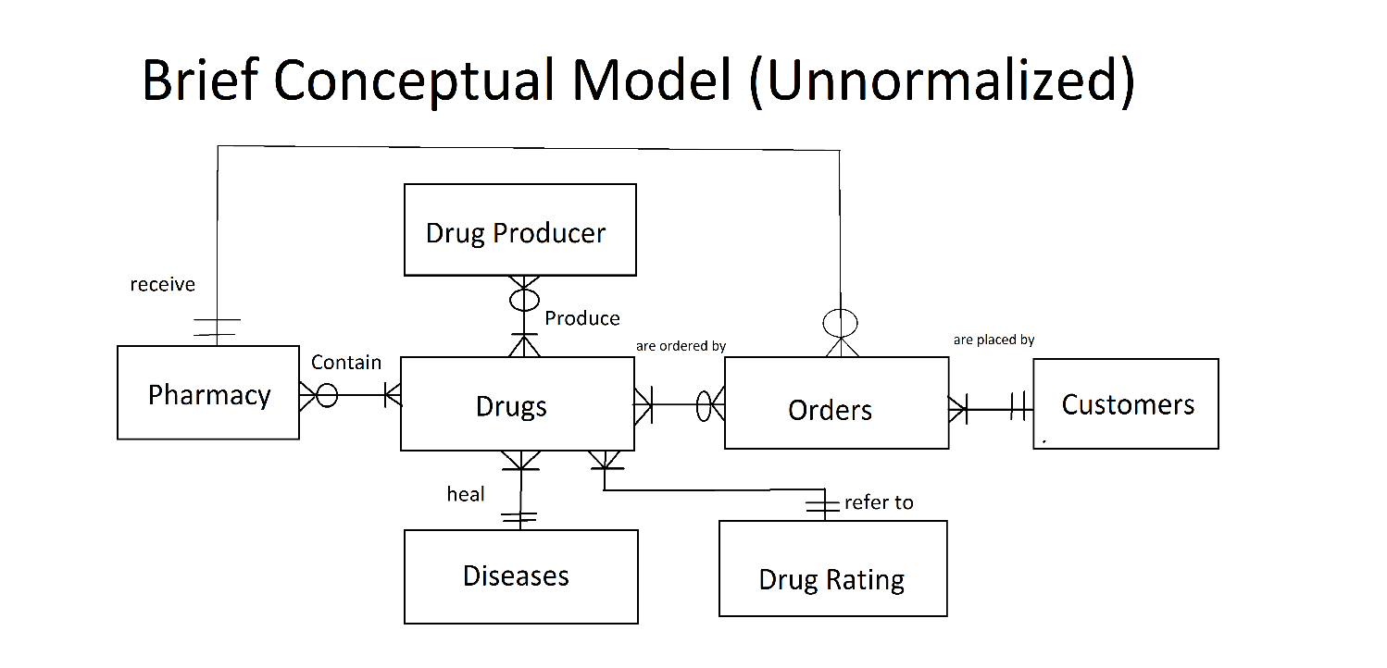

**Conceptual Design**

1. **Entity Relationship Modeling and Normalization**

Based on the above background description of business relationship between users and also the brief conceptual model of drug information system, our team has designed a more detailed and complete model for drug information system.



Compare the brief conceptual model and the entity relationship diagram, many M:N relationships are broken down in 1:M and M:1 relationship.

For the entity Drug Producer and Drugs, a composite entity Product is created so as to resolve the M:N relationship between Drug Producerand Drugs. A unique attribute Product_ID is used as the primary key instead of using composite key, Producer_ID and Drug_ID. Drug Producer and Product are in 1:M relationship since each drug producer can produce at least 1 or more drugs. Product and Drugs are in 0-or-many to 1 (M:1) relationship since Each type of drug may be produced by many drug producers or may not be produced by any drug producer.

For the entity Pharmacy and Product, a composite entity In-store Drugs is created so as to resolve the M:N relationship between Pharmacy and Product. Composite key Pharmacy_ID and Product_ID is used for the table. Pharmacy and In-store Drugs are in 1:M relationship since each pharmacy can contain at least 1 or more drugs produced by drug producers. In-store Drug and Product are in 0-or-many to 1 (M:1) relationship since there may be some drugs that are out of supply, no pharmacy containing that drug.

For the entity Product and Orders, a composite entity Order Items is created so as to resolve the M:N relationship between Product and Orders. Composite key Product_ID and Order_ID is used. Product and Order Items are in 1 to 0-or-many (1:M) relationship since the drugs may be ordered by many orders or may not be ordered by any order. Order Items and Orders are in M:1 relationship since each order contain at least 1 or more order items (drugs).

**Dependency Diagram**



Relational Schema: Diseases(Disease_Name, Disease_Symptoms, Degree of Danger, Type, Causes)



Relational Schema: Drug Producers(Producer_ID, Producer_Name, Country, Contact, Email, Date of Establishment)



Relational Schema: Drug Rating(Drug_Level, Level_Definition)

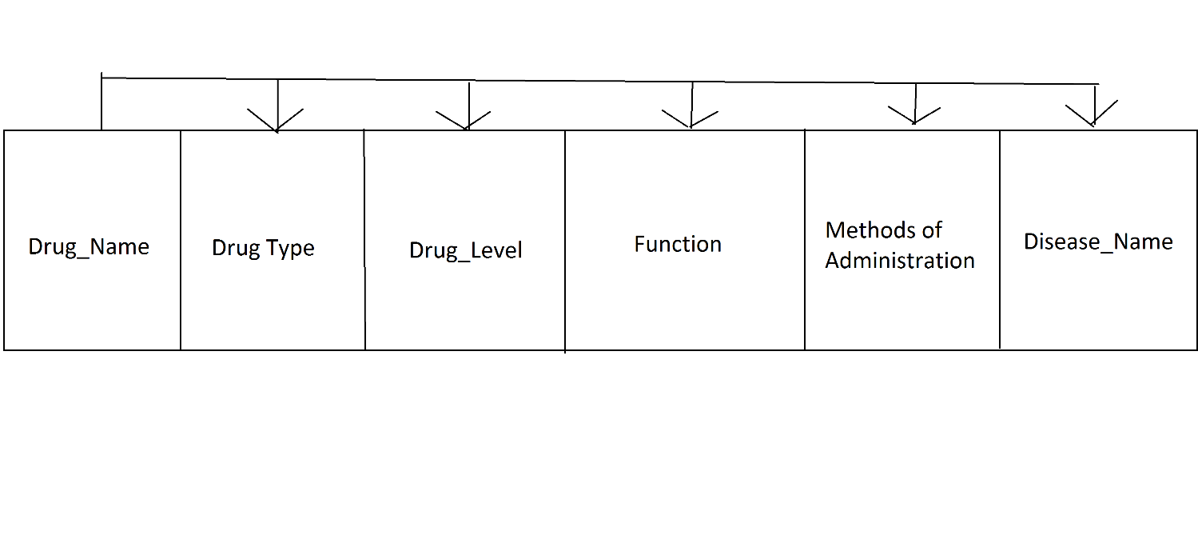

Relational Schema: Drugs(Drug_Name, Drug Type, Drug_Level#, Function, Methods of Administration, Disease_Name#)



Relational Schema: Orders(Order_ID, Customer_ID#, Pharmacy_ID#, Order_Date, Pickup_Date)



Relational Schema: OrderItems(Product_ID#, Order_ID#, Quantity)



Relational Schema: Pharmacy(Pharmacy_ID, Pharmacy_Name, District, Address, Contact, Email)

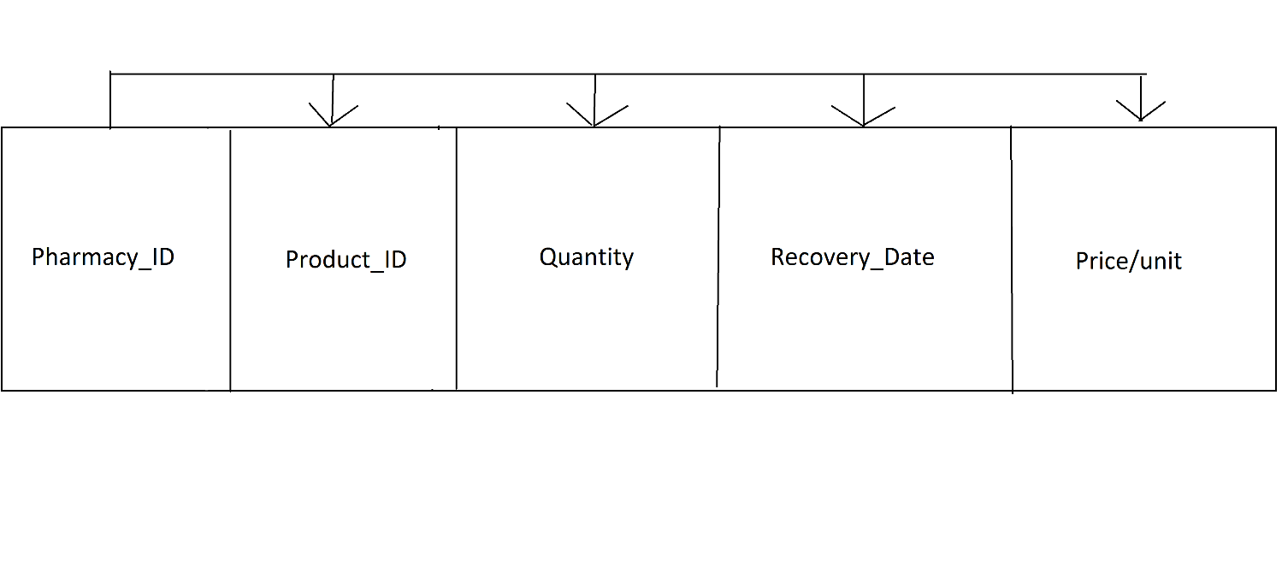

Relational Schema: In-store Drugs(Pharmacy_ID#, Product_ID#, Quantity, Recovery_Date, Price/unit)



Relational Schema: Customers(Customer_ID, FirstName, LastName, Organization_Name, Contact, Email, DOB, Address)

As shown from the above dependency diagram, all tables are in third normal form. All M:N relationship are resolved. Partial dependency and transitive dependency are removed. Therefore, many repeating groups are eliminated so as to reduce the insertion, deletion and modification anomalies.

1. **Distributed Database Design**

As mentioned in the above sections, Drug Information System should be used by the hospital authority, drug producer, pharmacy and customers. Therefore, distributed database system should be used for drug information system. The database system should be installed in all hospital authority ‘s workplaces. A web page should be hosted for customers to access to the database and place orders. It will also provide web service and generate email to the pharmacies to inform them the orders placed by the customers.

**Logical Design**

The following tables and attributes are all implemented within the environment of Microsoft Access.

1. **Translation of Conceptual Model to Logical Model**

|  |  |  |
| --- | --- | --- |
| Drug Producer | | |
| Concept | Transformation | Attribute |
| The key that can uniquely identify each drug producer | 🡪 | Producer_ID (PK) |
| Name of the drug producers | 🡪 | Producer_Name |
| The country that the drug producer(headquarter) is locating at | 🡪 | Country |
| The contact phone number for the drug producer, associated with area code | 🡪 | Contact |
| The contact email for the drug producer | 🡪 | Email |
| The date for the drug producer to set up | 🡪 | Date of Establishment |

|  |  |  |
| --- | --- | --- |
| Drugs | | |
| Concept | Transformation | Attribute |
| The generic name of a drug, which is usually a unique chemical-related name | 🡪 | Drug_Name (PK) |
| The type of a drug, which may be related to its composition or function | 🡪 | Drug_Type |
| The level of danger of that drug to the pregnant mothers | 🡪 | Drug_Level (FK) |
| All effects of the drug that will be produced after one take in the drugs | 🡪 | Function |
| The main disease that the drug targets | 🡪 | Disease_Name (FK) |
| The way(s) that people can take in the drug | 🡪 | Methods of Administration |

|  |  |  |
| --- | --- | --- |
| Product | | |
| Concept | Transformation | Attribute |
| The key that can uniquely identify each product produced by drug producers | 🡪 | Product_ID (PK) |
| The brand name of the product which is determined by drug producer (it is different from the generic name of drugs) | 🡪 | Product_Name |
| The generic name of the drug which is determined by government (hospital authority) | 🡪 | Drug_Name (FK) |
| The key used to map the drug with its producer | 🡪 | Producer_ID (FK) |
| The ingredients that the drug product contain | 🡪 | Ingredients |
| The year that the drug producer starts the production line for the specific drug | 🡪 | Year of Production |
| The explanation and description of the drug products made by drug producers | 🡪 | Product Description |

|  |  |  |
| --- | --- | --- |
| Pharmacy | | |
| Concept | Transformation | Attribute |
| The key that can uniquely identify each pharmacy in Hong Kong | 🡪 | Pharmacy_ID (PK) |
| The shop name of the pharmacy | 🡪 | Pharmacy_Name |
| The district that the pharmacy is locating at | 🡪 | District |
| The physical location of the pharmacy | 🡪 | Address |
| The contact phone number of the pharmacy | 🡪 | Contact |
| The contact email of the pharmacy | 🡪 | Email |

|  |  |  |
| --- | --- | --- |
| In-store Drugs | | |
| Concept | Transformation | Attribute |
| The key that uniquely identify a specific drug product in a pharmacy | 🡪 | Pharmacy_ID (PK, FK1) |
| Product_ID (PK, FK2) |
| The amount of drug products that the pharmacy contains | 🡪 | Quantity |
| The date that the drug producers would supply the drugs to pharmacy again. If the pharmacy does not know the recovery date, the recovery date would be null | 🡪 | Recovery_Date |
| The marked price of each drug product in pharmacy | 🡪 | Price/unit |

|  |  |  |
| --- | --- | --- |
| Diseases | | |
| Concept | Transformation | Attribute |
| The official standard term of a disease suggested by World Health Organization | 🡪 | Disease_Name (PK) |
| The symptoms of a disease suggested by World Health Organization | 🡪 | Disease_Symptoms |
| The extent of harmful effects on human caused by that disease | 🡪 | Degree of Danger |
| The area of body that would be damaged by that disease | 🡪 | Type |
| The reason why that the patients infect the disease and ways for the spread of those bacteria/virus/fungal | 🡪 | Causes |

|  |  |  |
| --- | --- | --- |
| Drug Rating | | |
| Concept | Transformation | Attribute |
| The extent of harmful effects of a drug on pregnant mothers | 🡪 | Drug_Level (PK) |
| The description of the drug level related to the side effects of a drug on the pregnant mothers or babies | 🡪 | Level_Definition |

|  |  |  |
| --- | --- | --- |
| Orders | | |
| Concept | Transformation | Attribute |
| The key that can uniquely identify each order placed by customers | 🡪 | Order_ID (PK) |
| The key that helps to refer the order to the corresponding customer | 🡪 | Customer_ID (FK) |
| The key used to describe in which pharmacy that the customer wants to place an order | 🡪 | Pharmacy_ID (FK) |
| The date for placing the order by customer | 🡪 | Order_Date |
| The date that the customer can get to their designed pharmacy to pick up their desired drugs  Note: The pickup date is the date that the customers’ ordered drug products are ready to be picked up  Pickup date ≠ The actual date that the customer gets to the designed pharmacy to pick up the drugs | 🡪 | Pickup_Date |

|  |  |  |
| --- | --- | --- |
| OrderItems | | |
| Concept | Transformation | Attribute |
| The ordered item(s) of each order placed by the customer | 🡪 | Order_ID (PK, FK1) |
| Product_ID (PK, FK2) |
| The amount of item that the customer wants to order | 🡪 | Quantity |

|  |  |  |
| --- | --- | --- |
| Customers | | |
| Concept | Transformation | Attribute |
| The key that can uniquely identify each customer | 🡪 | Customer_ID (PK) |
| First name of thecustomer | 🡪 | FirstName |
| Last name of the customer | 🡪 | LastName |
| If the customer is a representative of an organization, the official name of his/her organization is required. Otherwise, the customer doesn’t need to fill in the organization name | 🡪 | Organization_Name |
| The contact phone number of customer | 🡪 | Contact |
| The contact email of customer | 🡪 | Email |
| The date-of-birth of the customer or date-of-establishment of the organization | 🡪 | DOB |
| The physical location of the organization or the living place of individual customer | 🡪 | Address |

1. **Properties of Attributes in Tables**

The following lists all properties of all attributes in all tables:

|  |  |  |  |  |  |  |  |  |
| --- | --- | --- | --- | --- | --- | --- | --- | --- |
| **Customers** | | | | | | | | |
| Attribute | Customer_ID | FirstName | LastName | Organization_Name | Contact | Email | DOB | Address |
| Data Type | AutoNumber | Text | Text | Text | Text | Text | Date/Time | Text |
| Size | Long Integer | 10 | 10 | 50 | 12 | 50 | - | 255 |
| Format | - | - | - | - | - | - | Short Date | - |
| Decimal Places | - | - | - | - | - | - | - | - |
| Input Mask | - | - | - | - | - | - | 99/99/0000;0;_ | - |
| Default Value | - | - | - | - | - | - | - | - |
| Validation Rule | - | Not Like "*[!a-z]*" | Like "*[A-Z ]*" | Is Null Or Not Like "*[!0-9a-z ().'-]*" | Like "*[0-9]*" And Like "???-????????" | Is Null Or ((Like "*?@?*.?*") And (Not Like "*[ ,;]*")) | <=  Now() | - |
| Validation Text | - | Only letters are accepted | Only letters and space are accepted | Only letters, numbers, space, brackets, point, hyphen and approsophy are accepted | Follow the format: AreaCode-ContactNumber | Missing '@' or Unnecessary punctuation | Invalid date | - |
| Required | - | Yes | Yes | No | Yes | No | No | No |
| Allow Zero Length | - | No | No | Yes | No | Yes | - | Yes |
| Indexed | Yes(unduplicated) | No | No | No | No | No | No | No |

|  |  |  |  |  |  |  |
| --- | --- | --- | --- | --- | --- | --- |
| **Drugs** | | | | | | |
| Attribute | Drug_Name | Drug_Type | Drug_Level | Function | Methods of Administration | Disease_Name |
| Data Type | Text | Text | Text | Memo | Text | Text |
| Size | 100 | 20 | 1 | - | 255 | 20 |
| Format | - | - | - | - | - | - |
| Decimal Places | - | - | - | - | - | - |
| Input Mask | - | - | - | - | - | - |
| Default Value | - | - | - | - | - | - |
| Validation Rule | Not Like "*[!0-9a-z ().'-]*" | Not Like "*[!0-9a-z ()-]*" | In ('A','B','C','D','X') | - | - | Not Like "*[!0-9a-z ()-]*" |
| Validation Text | Only letters, numbers, space, brackets, point, hyphen and laparoscopy are accepted | Only letters, numbers, space, brackets, point, hyphen and laparoscopy are accepted | Drug level should either A, B, C, D or X | - | - | Only letters, numbers, space, brackets, point, hyphen and laparoscopy are accepted |
| Required | Yes | Yes | Yes | Yes | Yes | Yes |
| Allow Zero Length | No | No | No | No | No | No |
| Indexed | Yes  (unduplicated) | Yes  (duplicated) | Yes  (duplicated) | Yes  (duplicated) | No | Yes  (duplicated) |

|  |  |  |  |  |  |  |  |
| --- | --- | --- | --- | --- | --- | --- | --- |
| **Product** | | | | | | | |
| Attribute | Product_ID | Product_Name | Drug_Name | Producer_ID | Ingredients | Year of Production | Product Description |
| Data Type | AutoNumber | Text | Text | Number | Memo | Number | Memo |
| Size | Long Integer | 50 | 100 | Long Integer | - | Long Integer | - |
| Format | - | - | - | - | - | - | - |
| Decimal Places | - | - | - | Automatic | - | Automatic | - |
| Input Mask | - | - | - | - | - | - | - |
| Default Value | - | - | - | - | - | - | - |
| Validation Rule | - | Not Like "*[!0-9a-z ().'-]*" | Not Like "*[!0-9a-z ().'-]*" | >0 | - | <=Now() | - |
| Validation Text | - | Only letters, numbers, space, brackets, point, hyphen and approsophy are accepted | Only letters, numbers, space, brackets, point, hyphen and approsophy are accepted | Producer_ID should be >0 | - | The Year of Production should be before current time | - |
| Required | - | Yes | Yes | Yes | Yes | No | Yes |
| Allow Zero Length | - | No | No | - | No | - | No |
| Indexed | Yes  (unduplicated) | Yes  (duplicated) | Yes  (duplicated) | Yes  (duplicated) | Yes  (duplicated) | No | Yes  (duplicated) |

|  |  |  |  |  |  |  |
| --- | --- | --- | --- | --- | --- | --- |
| **Drug Producer** | | | | | | |
| Attribute | Producer_ID | Producer_Name | Country | Contact | Email | Date of Establishment |
| Data Type | AutoNumber | Text | Text | Text | Text | Date/Time |
| Size | Long Integer | 50 | 20 | 12 | 50 |  |
| Format | - | - | - | - | - | Short Date |
| Decimal Places | - | - | - | - | - | - |
| Input Mask | - | - | - | - | - | 99/99/0000;0;_ |
| Default Value | - | - | - | - | - | - |
| Validation Rule | - | Not Like "*[!0-9a-z ().'-]*" | Not Like "*[!a-z ]*" | Like "*[0-9]*" And Like "???-????????" | Is Null Or ((Like "*?@?*.?*") And (Not Like "*[ ,;]*")) | <=Now() |
| Validation Text | - | Only letters, numbers, space, brackets, point, hyphen and approsophy are accepted | Only letters and space are accepted | Follow the format: AreaCode-ContactNumber | Missing '@' or Unnecessary punctuation | The date should be before the current time |
| Required | - | Yes | Yes | Yes | No | No |
| Allow Zero Length | - | No | No | No | Yes | - |
| Indexed | Yes  (unduplicated) | Yes  (duplicated) | Yes  (duplicated) | No | No | No |

|  |  |  |  |  |  |  |
| --- | --- | --- | --- | --- | --- | --- |
| **Pharmacy** | | | | | | |
| Attribute | Pharmacy_ID | Pharmacy_Name | District | Address | Contact | Email |
| Data Type | AutoNumber | Text | Text | Text | Number | Text |
| Size | Long Integer | 50 | 15 | 255 | Long Integer | 50 |
| Format | - | - | - | - | - | - |
| Decimal Places | - | - | - | - | 0 | - |
| Input Mask | - | - | - | - | - | - |
| Default Value | - | - | - | - | - | - |
| Validation Rule | - | Not Like "*[!0-9a-z ().'-]*" | Not Like "*[!a-z ]*" | - | Like "[2,3,5,6,9]#######" | Is Null Or ((Like "*?@?*.?*") And (Not Like "*[ ,;]*")) |
| Validation Text | - | Only letters, numbers, space, brackets, point, hyphen and approsophy are accepted | Only letters and space are accepted | - | Improper length or not starting with "2", "3", "5", "6"or "9" | Missing '@' or Unnecessary punctuation |
| Required | - | Yes | Yes | Yes | Yes | No |
| Allow Zero Length | - | No | No | No | - | Yes |
| Indexed | Yes  (unduplicated) | Yes  (duplicated) | Yes  (duplicated) | Yes  (unduplicated) | No | No |

|  |  |  |  |  |  |
| --- | --- | --- | --- | --- | --- |
| **In-store Drugs** | | | | | |
| Attribute | Pharmacy_ID | Product_ID | Quantity | Recovery_Date | Price/unit |
| Data Type | Number | Number | Number | Date/Time | Currency |
| Size | Long Integer | Long Integer | Long Integer | Short Date | - |
| Format | - | - | - | Short Date | - |
| Decimal Places | 0 | 0 | 0 | - | - |
| Input Mask | - | - | - | 99/99/0000;0;_ | - |
| Default Value | - | - | - | - | - |
| Validation Rule | >0 | >0 | >=0 | >=Now() | >0 |
| Validation Text | - | - | - | - | - |
| Required | Yes | Yes | Yes | No | Yes |
| Allow Zero Length | - | - | - | - | - |
| Indexed | Yes  (duplicated) | Yes  (duplicated) | Yes  (duplicated) | Yes  (duplicated) | Yes  (duplicated) |

|  |  |  |  |  |  |
| --- | --- | --- | --- | --- | --- |
| **Diseases** | | | | | |
| Attribute | Disease_Name | Disease_Symptoms | Degree of Danger | Type | Causes |
| Data Type | Text | Memo | Number | Text | Memo |
| Size | 20 | - | Bit | 10 | - |
| Format | - | - | - | - | - |
| Decimal Places | - | - | 0 | - | - |
| Input Mask | - | - | - | - | - |
| Default Value | - | - | - | - | - |
| Validation Rule | Not Like "*[!0-9a-z ().'-]*" | - | >0 | Not Like "*[!a-z ]*" | - |
| Validation Text | Only letters, numbers, space, brackets, point, hyphen and approsophy are accepted | - | - | Only letters and space are accepted | - |
| Required | Yes | Yes | Yes | No | No |
| Allow Zero Length | No | No | - | Yes | Yes |
| Indexed | Yes  (unduplicated) | No | Yes  (duplicated) | No | No |

|  |  |  |
| --- | --- | --- |
| **Drug Rating** | | |
| Attribute | Drug_Level | Level_Definition |
| Data Type | Text | Text |
| Size | 1 | 255 |
| Format | - | - |
| Decimal Places | - | - |
| Input Mask | - | - |
| Default Value | - | - |
| Validation Rule | In ('A','B','C','D','X') | - |
| Validation Text | Drug level should either A, B, C, D or X | - |
| Required | Yes | Yes |
| Allow Zero Length | No | No |
| Indexed | Yes  (unduplicated) | No |

|  |  |  |  |  |  |
| --- | --- | --- | --- | --- | --- |
| **Orders** | | | | | |
| Attribute | Order_ID | Customer_ID | Pharmacy_ID | Order_Date | Pickup_Date |
| Data Type | AutoNumber | Number | Number | Date/Time | Date/Time |
| Size | Long Integer | Long Integer | Long Integer | - | - |
| Format | - | - | - | Short Date | Short Date |
| Decimal Places | - | Automatic | Automatic | - | - |
| Input Mask | - | - | - | 99/99/0000;0;_ | 99/99/0000;0;_ |
| Default Value | - | - | - | - | - |
| Validation Rule | - | >0 | >0 | <=Now() | - |
| Validation Text | - | - | - | The order date -should be on or before current time | - |
| Required | - | Yes | Yes | Yes | No |
| Allow Zero Length | - | - | - | - | - |
| Indexed | Yes  (unduplicated) | Yes  (duplicated) | Yes  (duplicated) | No | Yes  (duplicated) |

For the attribute Order_Date and Pickup_Date, the Pickup_Date should be the date after the Order_Date. However, this rule cannot be implemented normally as it is not a valid SQL. Expression Builder in Microsoft Access are needed so as to construct this rule.

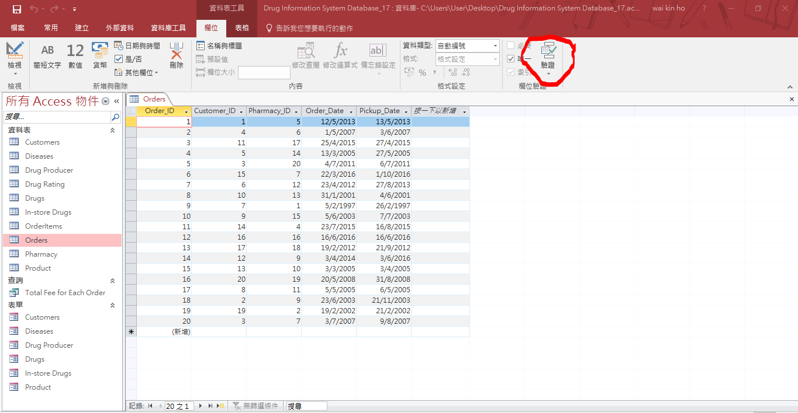

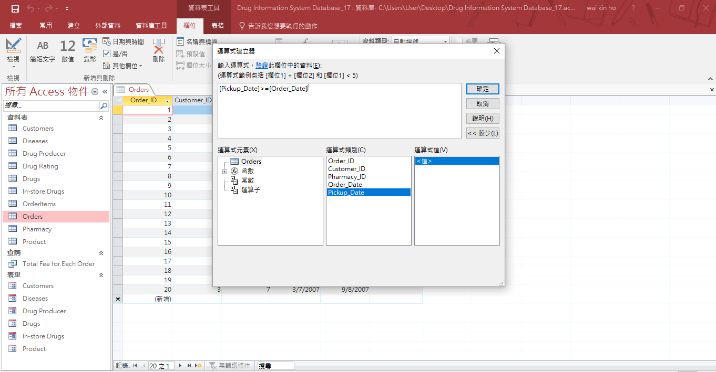

|  |  |  |  |
| --- | --- | --- | --- |
| **OrderItems** | | | |
| Attribute | Order_ID | Product_ID | Quantity |
| Data Type | Number | Number | Number |
| Size | Long Integer | Long Integer | Long Integer |
| Format | - | - | - |
| Decimal Places | Automatic | Automatic | Automatic |
| Input Mask | - | - | - |
| Default Value | - | - | - |
| Validation Rule | >0 | >0 | >0 |
| Validation Text | - | - | - |
| Required | Yes | Yes | Yes |
| Allow Zero Length | - | - | - |
| Indexed | Yes  (duplicated) | Yes  (duplicated | Yes  (duplicated |

1. **Data Security Control: Integrity Reinforcement**

Microsoft Access support build-in function for enhancing data security, entity integrity and referential integrity, which eventually maximizes data consistency and minimizes data redundancy. As shown below, tables’ relationships can be constructed Edit Relationships function. Foreign key of a table can be easily referenced to the primary key of other table through this function.

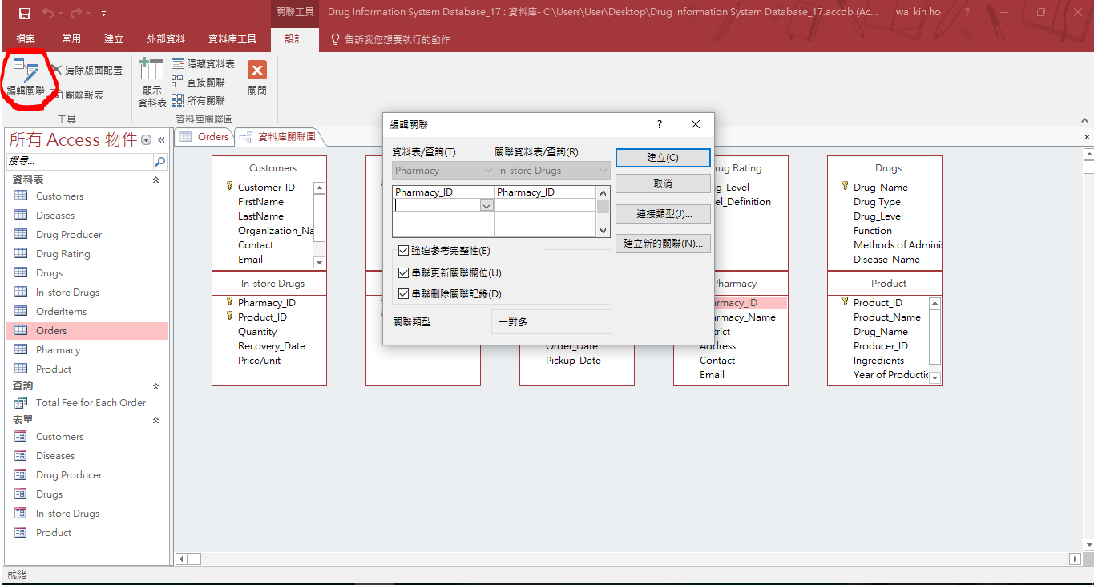

After construct all relationships between tables according to the ERD, Access shows the following:

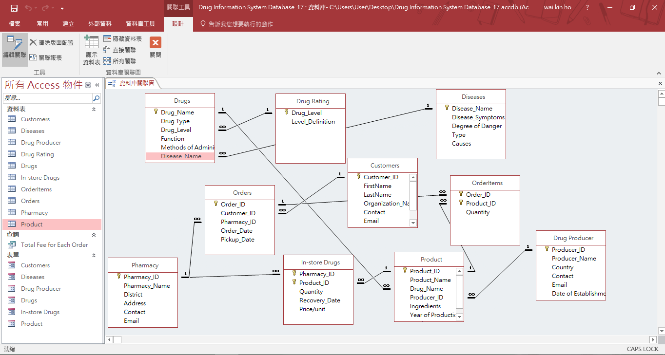

After building the relationships, many input errors can be avoided due to the referential integrity. Error message will be popped out if the users have entered data that are logically incorrect.

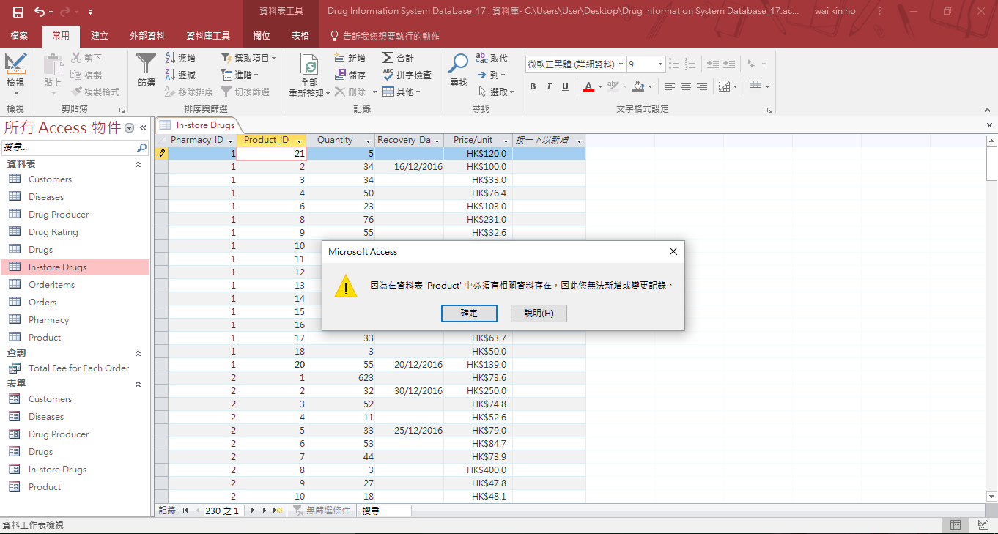

**Physical Design Medium**

1. **Selection of Database Management System**

Based on the background information of Drug Information System, Microsoft Access 2016 will be selected for Database Management System. There are five reasons for making this decision.

First, Microsoft Access can minimize the operating cost due to its inexpensive economic fee. According to the official site of Microsoft, only HKD$272/user is needed for the most advanced version for enterprise version E5, and also including other software suites of Microsoft such as Microsoft Word. Compare with Oracle Database’s license fee, which costs USD$47500/user, Microsoft Access would be a better choice.

Second, Microsoft Access causes a light burden on the computers’ storage devices. The storage space requirement for installing Microsoft Access is 1GB or more hard disk space according to the official site of Microsoft. Compare with Oracle Database, which requires around 4GB hard disk space for installation, Microsoft Access is a better choice for saving storage space and reducing the heavy work load of the computers’ storage devices.

Third, Microsoft Access supports simple features and practical tools that can drastically arouse working efficiency. For example, it provides multiple templates that allow users to customize their own database. Also, it provides wizard creation, form design, query design and report generation. Besides, it introduces customizable web apps to streamline data processing for users and to make collaboration on drug information system more easily. The biggest benefit would be the easy-to-use features which require low IT skills from the hospital authority’s staffs so they can work on the database quickly. Compare with Oracle database, Oracle Database is more complicated since it is driven by a complex engine. For example, it provides automated failover (Oracle Data Guard) and handles both OLTP and OLAP simultaneously, which require high level IT skills to manipulate them. Thus, Microsoft Access would be a better choice for easy usage.

Fourth, Microsoft Access has high portability. It can easily be installed by following the guidelines of its internal install wizard. Step-by-step processes will be done with the installation procedures. Only a single zipped file is needed for installation.

Fifth, Microsoft Access has high mobility for data exchange. For example, it supports data export and data import between text file, XML file, ODBC Database and html document. This constructs an effective communication bridge between the data of Drug Information System and other software suites. The high mobility of data allows the users to operate the data of Drug Information System in more flexible ways, which in turn benefits the development and maintenance for Drug Information System.

1. **Data Storage Medium**

Since there are 10 tables in the database system, approximately at least 1TB storage capacity is needed for data storage.

First, JBOD (just a brunch of disks) should be used for daily operations for the database. JBOD is a collection of old fashioned internal hard disk drives which has large storage capacity so as to store a large amount of data. Also, it has fast access speed since data is accessed in random access manner which favors the operations for the database, such as inserting, deleting and altering records. Furthermore, the cost for JBOD is cheaper compared with solid-state drive (SSD) and storage area network(SAN). However, it is not expandable enough.

Second, network-attached storage (NAS) should be used for data backup of the database system. Network-attached storage has a cheap cost, large storage capacity and it is highly expandable which helps users to back up the data. However, it has slow data access speed which does not favor daily operations for database.

1. **Source of Data**

In Drug Information System, numerous data elements have to be collected from pharmacies, drug producers, customers and hospital authority so as to construct an all-rounded and efficient database system.

In terms of the pharmacies, they are responsible to provide their own pharmacy information such as the pharmacy name, district, address, contact number and email (Table: Pharmacy). Apart from their organization information, they need to provide detailed information for their in-store drugs, such as the drug product they contained and the corresponding quantity and also the recovery date (the date that the drug producer can supply the drugs to the pharmacy) (Table: In-store Drugs). In addition, the pharmacies are responsible to process the orders placed by customers. They have to inform the customers about the pickup date, the date that the customers can get to the pharmacy and pick up their desired products (Table: Orders).

In terms of the drug producers, they are responsible to provide their organization information, such as the producer name, country, contact number, email and date of establishment (Table: Drug Producer). Moreover, they have to provide the information related to the drug products that they produced, such as the product name, drug name (generic name), ingredients, year of production and product description (Table: Product).

In terms of the customers, they are responsible to provide their personal information to the pharmacies, such as their first name, last name, organization name (if they are the representative of an organization), contact number, email, date-of-birth and address (Table: Customers). Also, they have to provide the information about the products that they want to order in a specified pharmacy, such as the drug product and quantity (Table: Order Items).

In terms of the hospital authority, they are responsible to provide the diseases’ name, symptoms, degree of danger, type and causes (Table: Diseases). Besides, they have to provide the information of the drug level and the corresponding level definition (Table: Drug Rating) so as to remind the pregnant mothers. Furthermore, they have to provide the chemical drug information, such as the drug name (known as the official generic name), type, level, function, corresponding disease and method of administration (Table: Drugs).

1. **Security Measures: User’s Access Rights and Privileges**

In order to protect user’s interests, different users have different access right and privileges.

|  |  |  |
| --- | --- | --- |
| User/End-user | Table(s) that can be accessed | Access Rights and Privileges |
| Each pharmacy | Pharmacy, In-store Drugs, Orders, OrderItems, Customer | Allowed to modify and update its own organization information (Table: Pharmacy), product items they contain (Table: In-store Drugs), the attribute Pickup_Date (Table: Orders)  Allowed to view the table OrderItems but not any modification or update  Allowed to view the table Customers but only the attributes, FirstName, LastName, Organization_Name and Contact but not any modification or update |
| Each customer | Customers, Orders, OrderItems | Allowed to modify and update his/her own personal information (Table: Customers), select their desired pharmacy (Table: Order), select their desired products and the corresponding quantity (Table: OrderItems)  Not allowed to modify the attribute Pickup_Date in table Orders |
| Each drug producer | Drug Producers, Product | Allowed to modify and update its own organization information (Table: Drug Producers) and its product information (Table: Product) |
| Government | All tables | Manage all data in tables and relationships since government is the system administrator |

**Implementation Details**

1. **Flow Chats of the Program**

|  |  |
| --- | --- |
| Program Procedures | Description |
| 1 | Customers would register the fill their personal information through a program |
| 2 | Personal information of customers will be validated, sent and stored in the database system |
| 3 | The customers view and select their desired drugs and pharmacy and place an order for the drug product. |
| 4 | The data are validated and sent to the pharmacy |
| 5 | The pharmacy receives the orders the update the pickup date of the orders if there is enough supply for the orders |
| 6 | The customers receive their desired drug products |

1. **Sample Results with Explanation**
   1. **Queries Design**

|  |  |  |  |
| --- | --- | --- | --- |
| **Target** | **Query Name** | **SQL** | **Purpose** |
| Customers | 1. Detailed Information for Drug Products | SELECT Product_ID AS [Product ID], Product_Name AS Product, Product.Drug_Name AS [Generic Name], Disease_Name AS [Target Disease], Producer_Name AS Producer, [Drug Producer].Country, Ingredients, [Year of Production], [Product Description], Level_Definition AS [Influence to Mothers]  FROM Product, Drugs, [Drug Producer], [Drug Rating]  WHERE Drugs.Drug_Name=Product.Drug_Name AND Product.Producer_ID=[Drug Producer].Producer_ID AND Drugs.Drug_Level=[Drug Rating].Drug_Level  ORDER BY Product.Drug_Name, Disease_Name, [Drug Producer].Country, Product_ID; | Used to display the complete information of a drug product to users, such as the product id, product name, generic name, target disease, producer, country, ingredients, year of production, product description and influence to mothers |
| 1. Drug Products for Chronic | SELECT Product_ID AS [Product ID], Product_Name AS [Product Name], Product.Drug_Name AS [Drug Name], Producer_Name AS Producer, Ingredients, [Year of Production], [Product Description]  FROM PRODUCT, DISEASES, DRUGS, [Drug Producer]  WHERE PRODUCT.DRUG_NAME=DRUGS.DRUG_NAME AND TYPE='Chronic' AND DRUGS.DISEASE_NAME=DISEASES.DISEASE_NAME AND PRODUCT.PRODUCER_ID=[Drug Producer].PRODUCER_ID; | Used to filter the drug products, display the drugs that are used to treat chronic disease |
| 1. Drug Products for Infectious | SELECT Product_ID AS [Product ID], Product_Name AS [Product Name], Product.Drug_Name AS [Drug Name], Producer_Name AS Producer, Ingredients, [Year of Production], [Product Description]  FROM PRODUCT, DISEASES, DRUGS, [Drug Producer]  WHERE PRODUCT.DRUG_NAME=DRUGS.DRUG_NAME AND TYPE='Infectious' AND DRUGS.DISEASE_NAME=DISEASES.DISEASE_NAME AND PRODUCT.PRODUCER_ID=[Drug Producer].PRODUCER_ID; | Used to filter the drug products, display the drugs that are used to treat infectious disease |
| 1. Drug Products for Intestinal | SELECT Product_ID AS [Product ID], Product_Name AS [Product Name], Product.Drug_Name AS [Drug Name], Producer_Name AS [Producer Name], Ingredients, [Year of Production], [Product Description]  FROM PRODUCT, DISEASES, DRUGS, [Drug Producer]  WHERE PRODUCT.DRUG_NAME=DRUGS.DRUG_NAME AND TYPE='Intestinal' AND DRUGS.DISEASE_NAME=DISEASES.DISEASE_NAME AND PRODUCT.PRODUCER_ID=[Drug Producer].Producer_ID; | Used to filter the drug products, display the drugs that are used to treat intestinal disease |
| 1. Drug Products for Month | SELECT Product_ID AS [Product ID], Product_Name AS [Product Name], Product.Drug_Name AS [Drug Name], Producer_Name AS [Producer Name], Ingredients, [Year of Production], [Product Description]  FROM PRODUCT, DISEASES, DRUGS, [Drug Producer]  WHERE PRODUCT.DRUG_NAME=DRUGS.DRUG_NAME AND TYPE='Month' AND DRUGS.DISEASE_NAME=DISEASES.DISEASE_NAME AND PRODUCT.PRODUCER_ID=[Drug Producer].PRODUCER_ID; | Used to filter the drug products, display the drugs that are used to treat month disease |
| 1. Drug Products for Nail | SELECT Product_ID AS [Product ID], Product_Name AS [Product Name], Product.Drug_Name AS [Drug Name], Producer_Name AS [Producer Name], Ingredients, [Year of Production], [Product Description]  FROM PRODUCT, DISEASES, DRUGS, [Drug Producer]  WHERE PRODUCT.DRUG_NAME=DRUGS.DRUG_NAME AND TYPE='Nail' AND DRUGS.DISEASE_NAME=DISEASES.DISEASE_NAME AND PRODUCT.PRODUCER_ID=[Drug Producer].Producer_ID; | Used to filter the drug products, display the drugs that are used to treat nail disease |
| 1. Drug Products for Skin | SELECT Product_ID AS [Product ID], Product_Name AS [Product Name], Product.Drug_Name AS [Drug Name], Producer_Name AS [Producer Name], Ingredients, [Year of Production], [Product Description]  FROM PRODUCT, DISEASES, DRUGS, [Drug Producer]  WHERE PRODUCT.DRUG_NAME=DRUGS.DRUG_NAME AND TYPE='Skin' AND DRUGS.DISEASE_NAME=DISEASES.DISEASE_NAME AND PRODUCT.PRODUCER_ID=[Drug Producer].Producer_ID; | Used to filter the drug products, display the drugs that are used to treat skin disease |
| 1. Pharmacies Ordered by District | SELECT Pharmacy_ID AS [Pharmacy ID], Pharmacy_Name AS Pharmacy, District, Address, Contact, Email  FROM PHARMACY  ORDER BY DISTRICT; | Used to order the pharmacies by district which helps customers to locate the pharmacy that is closest to him/her |
| Pharmacy | 1. Highest Demanded Drug(s) | SELECT ORDERITEMS.PRODUCT_ID AS [Product ID], Product_Name AS Product, PRODUCT.Drug_Name AS [Drug Name], Disease_Name AS [Target Disease], Producer_Name AS Producer, Ingredients, [Year of Production], [Product Description], SUM(Quantity) AS [Number of Demand]  FROM ORDERITEMS, PRODUCT, [Drug Producer], DRUGS  WHERE ORDERITEMS.PRODUCT_ID=PRODUCT.PRODUCT_ID AND PRODUCT.PRODUCER_ID=[Drug Producer].PRODUCER_ID AND DRUGS.DRUG_NAME=PRODUCT.DRUG_NAME  GROUP BY ORDERITEMS.PRODUCT_ID, Product_Name, PRODUCT.Drug_Name, Producer_Name, Ingredients, [Year of Production], [Product Description], DISEASE_NAME  HAVING SUM(Quantity)>=ALL(SELECT SUM(Quantity) FROM ORDERITEMS GROUP BY PRODUCT_ID); | Remind the pharmacy about the highest demanded drug product so they can purchase the drugs from drug producer in large bulks |
| 1. Orders That Are Not Processed | SELECT Order_ID AS [Order ID], FirstName AS [First Name], LastName AS [Last Name], Pharmacy_Name AS [Pharmacy Name], Order_Date AS [Order Date], Pickup_Date AS [Pickup Date]  FROM ORDERS, Customers, Pharmacy  WHERE Orders.Customer_ID=Customers.Customer_ID And Pharmacy.Pharmacy_ID=Orders.Pharmacy_ID And PICKUP_DATE > NOW() OR PICKUP_DATE IS NULL  ORDER BY Pickup_Date; | Find out the orders in which its pickup date is in the future date/time (not the current time) or the pickup date is null.  Remind the pharmacy those orders have not been processed yet |
| 1. Total Fee for Each Order | SELECT Orders.Order_ID AS [Order ID], FirstName AS [First Name], LastName AS [Last Name], Organization_Name AS Organization, Pharmacy_Name AS Pharmacy, Product_Name AS Product, OrderItems.Quantity, [In-store Drugs].[Price/unit]*OrderItems.Quantity AS [Total Fee]  FROM [In-store Drugs], OrderItems, Orders, Customers, Product, Pharmacy  WHERE (((Orders.Order_ID)=OrderItems.Order_ID) And (([In-store Drugs].Pharmacy_ID)=Orders.Pharmacy_ID) And (([In-store Drugs].Product_ID)=OrderItems.Product_ID)) And Customers.Customer_ID=Orders.Customer_ID And Pharmacy.Pharmacy_ID=Orders.Pharmacy_ID And Product.Product_ID=OrderItems.Product_ID  ORDER BY Orders.Order_ID; | Calculate the require fee for each order which assists pharmacy in the transactions |
| 1. Total Ordered Amount for Each Product | SELECT ORDERITEMS.PRODUCT_ID AS [Product ID], Product_Name AS [Product Name], Drug_Name AS [Drug Name], Producer_Name AS Producer, Ingredients, [Year of Production], [Product Description], SUM(Quantity) AS [Total Ordered Amount]  FROM ORDERITEMS, PRODUCT, [Drug Producer]  WHERE ORDERITEMS.PRODUCT_ID=PRODUCT.PRODUCT_ID AND PRODUCT.PRODUCER_ID=[Drug Producer].PRODUCER_ID  GROUP BY ORDERITEMS.PRODUCT_ID, Product_Name, Drug_Name, Producer_Name, Ingredients, [Year of Production], [Product Description]  ORDER BY 8; | Sum up the amount of the drug products which are ordered by customers so as to help the pharmacy to estimate how many drug products they should purchase |
| Drug Producer | 1. Highest Demanded Drug(s) | SELECT ORDERITEMS.PRODUCT_ID AS [Product ID], Product_Name AS Product, PRODUCT.Drug_Name AS [Drug Name], Disease_Name AS [Target Disease], Producer_Name AS Producer, Ingredients, [Year of Production], [Product Description], SUM(Quantity) AS [Number of Demand]  FROM ORDERITEMS, PRODUCT, [Drug Producer], DRUGS  WHERE ORDERITEMS.PRODUCT_ID=PRODUCT.PRODUCT_ID AND PRODUCT.PRODUCER_ID=[Drug Producer].PRODUCER_ID AND DRUGS.DRUG_NAME=PRODUCT.DRUG_NAME  GROUP BY ORDERITEMS.PRODUCT_ID, Product_Name, PRODUCT.Drug_Name, Producer_Name, Ingredients, [Year of Production], [Product Description], DISEASE_NAME  HAVING SUM(Quantity)>=ALL(SELECT SUM(Quantity) FROM ORDERITEMS GROUP BY PRODUCT_ID); | Remind the drug producers that the drug is highly demanded so they should produce more for that drug |
| Government | 1. The Most Serious Disease in Hong Kong | SELECT DISEASES.Disease_Name AS Disease, Disease_Symptoms, [Degree of Danger], Type, Causes  FROM ORDERITEMS, PRODUCT, [Drug Producer], DRUGS, DISEASES  WHERE ORDERITEMS.PRODUCT_ID=PRODUCT.PRODUCT_ID AND PRODUCT.PRODUCER_ID=[Drug Producer].PRODUCER_ID AND DRUGS.DRUG_NAME=PRODUCT.DRUG_NAME AND DRUGS.DISEASE_NAME=DISEASES.DISEASE_NAME  GROUP BY ORDERITEMS.PRODUCT_ID, Product_Name, PRODUCT.Drug_Name, Producer_Name, Ingredients, [Year of Production], [Product Description], DISEASES.DISEASE_NAME, Disease_Symptoms, [Degree of Danger], Type, Causes  HAVING SUM(Quantity)>=ALL(SELECT SUM(Quantity) FROM ORDERITEMS GROUP BY PRODUCT_ID); | This is associated with the query “Highest Demanded Drug(s)”. Since the higher demand of a drug implies the higher seriousness of the corresponding disease.  This helps government to investigate and formulate some new policies to prevent citizens suffering from that disease |

* 1. **Form Design**

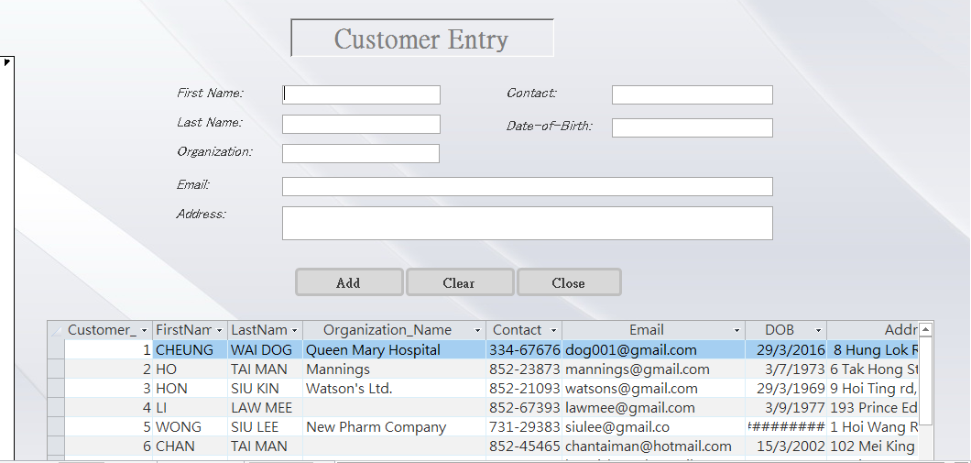

The first form of the database is called Customer Entry Form which is used to for users to enter the personal information of each customer.

The “Add” button is used for adding record to the table after the customers entered all their data. VBA is used with “Add” button so as to add a new record to the table Customer and requery the subform. The subform is used for the user to confirm that new record can be inserted to the table since the subform will be requeryed after a successful insertion of new record. If the insertion of record is unsuccessful, the subform would not be requeryed.

Before

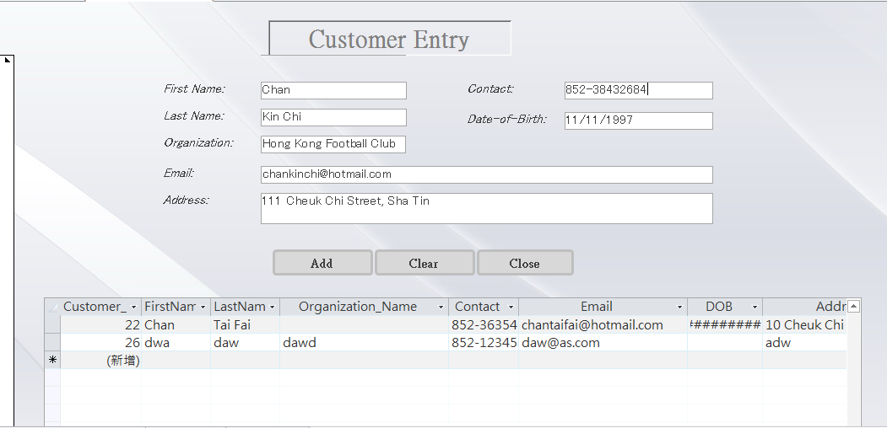

After (“Add” button is clicked)

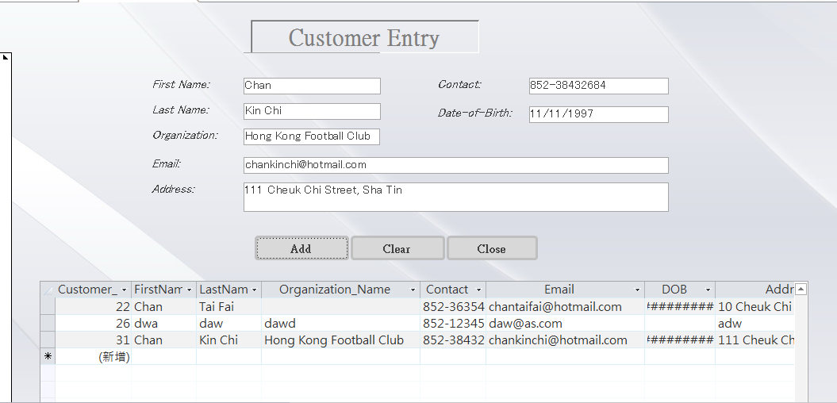

The “Clear” button is used to clear all the data entered if the users have found any mistake. VBA is also used with “Clear” button so as to reset the text in text fields.

Before



After (“Clear” button is clicked)

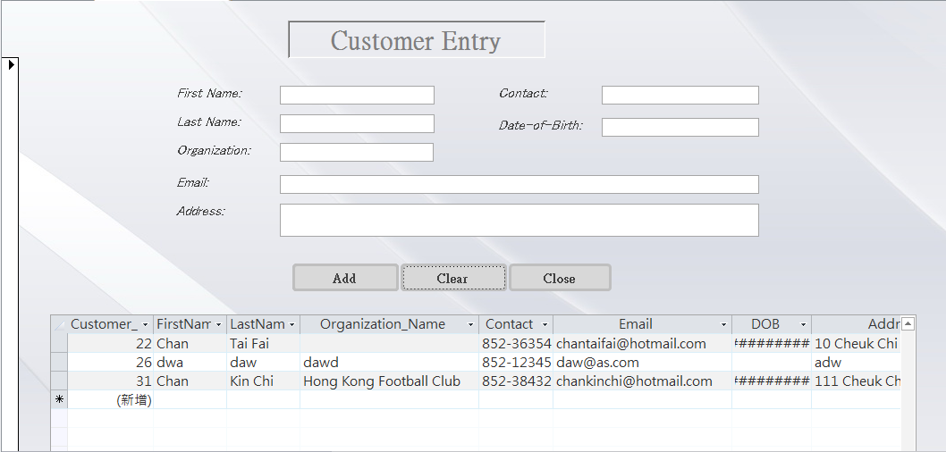

The “Close” button is implemented by embedded macro so as to allow users to close the form.

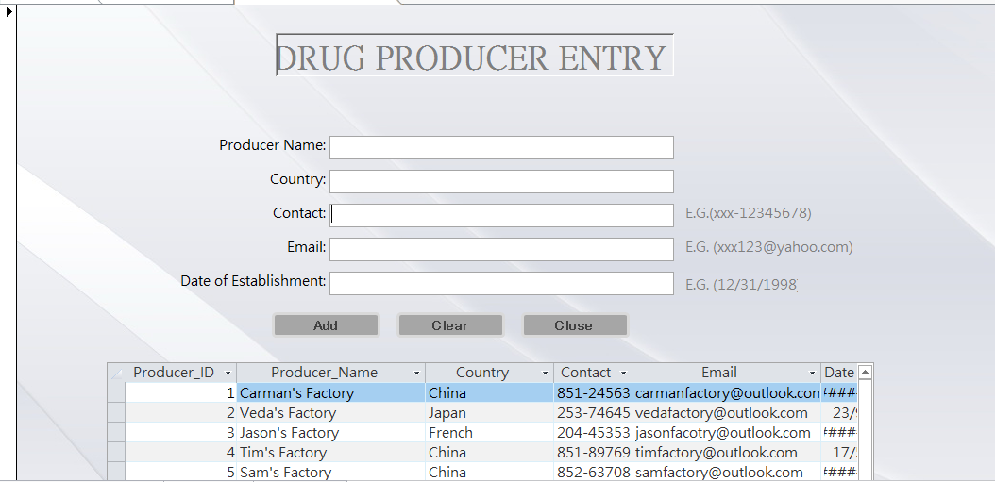

The second form of the database is called Drug Producer Entry Form for users to enter the organization information for each drug producer.

The “Add”, “Clear” and “Close” buttons have the same function performed as the Customer Entry Form.

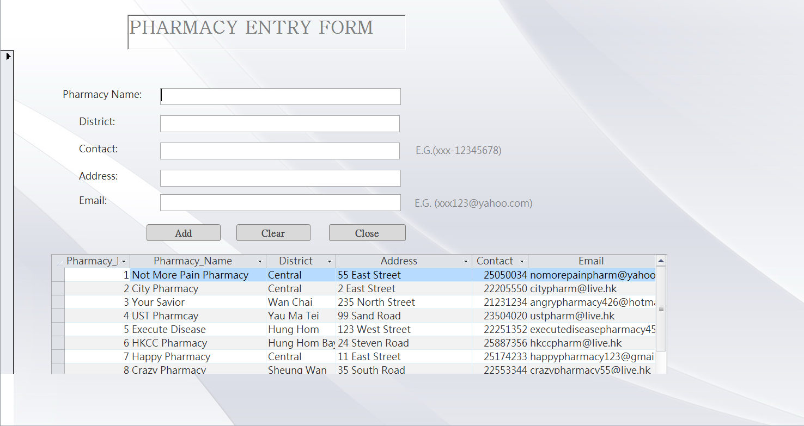

The third form of the database is called Pharmacy Entry Form for users to enter the organization information for each pharmacy.

The “Add”, “Clear” and “Close” buttons have the same function performed as the Customer Entry Form.

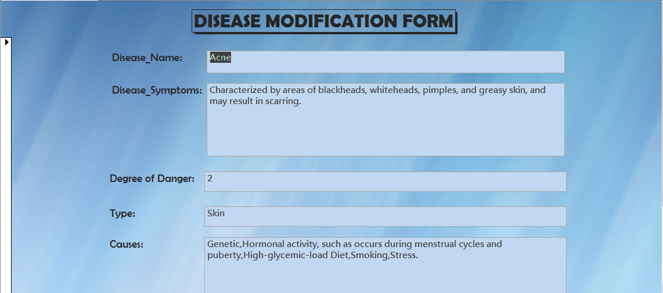



The fourth form of the database is called Disease Modification Form which allows users to modify the data in table Diseases.

The design of this form allows users to view the records in the table one by one. There are 5 buttons at the bottom of the form. The leftmost one is used to help users to view the previous record. The one next to it is used to help users to view the next record. The middle one is used to help users to save the changes made on the specific record. The right one next to the “Save” button is “Undo” button which allows users to undo the changes if they find any errors. The last one is used for users to delete a specific record from the table.

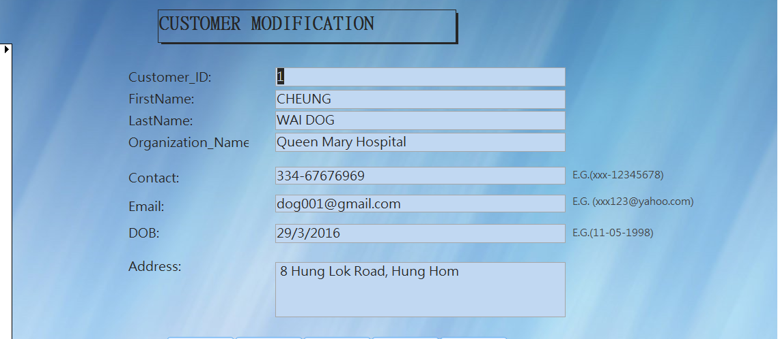



The fifth one performs the function for users to modify the existing data of the records of the table Customers.

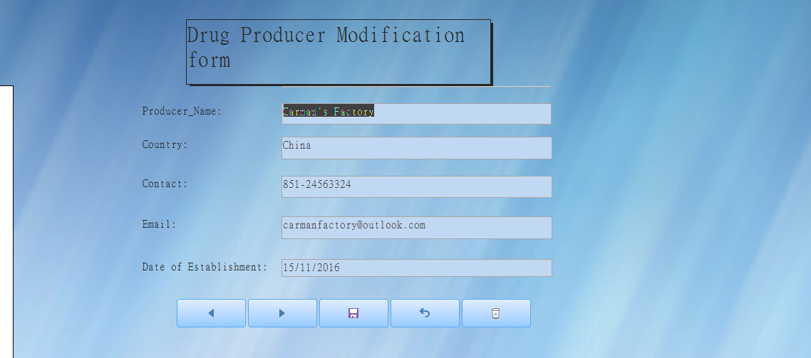

The sixth one performs the function for users to modify the existing data of the records of the table Drug Producer.

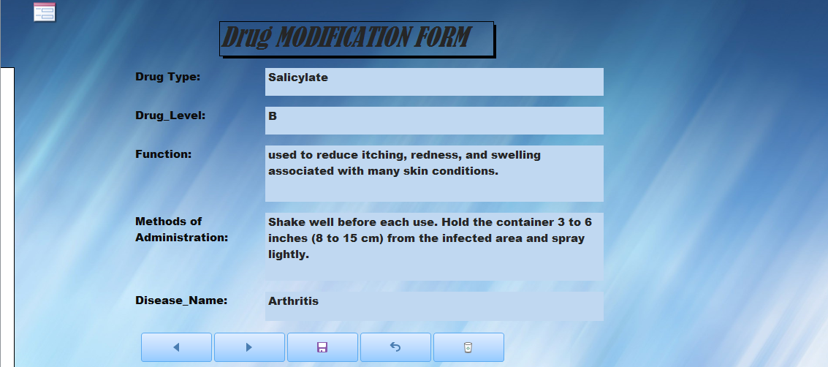

The seventh one performs the function for users to modify the existing data of the records of the table Drugs.

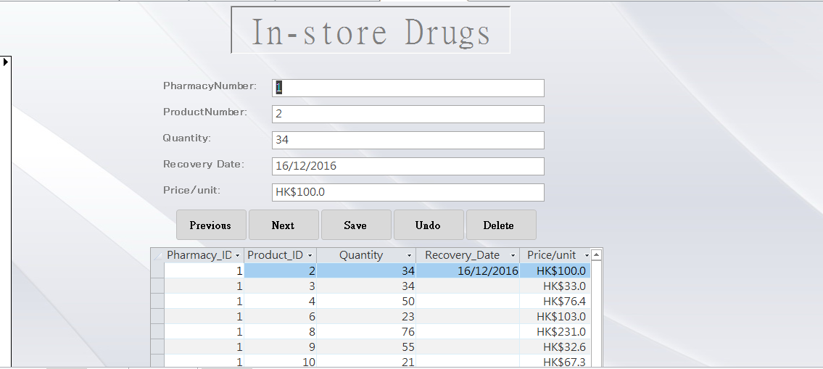

The eighth one performs the function for users to modify the existing data of the records of the table In-store Drugs.

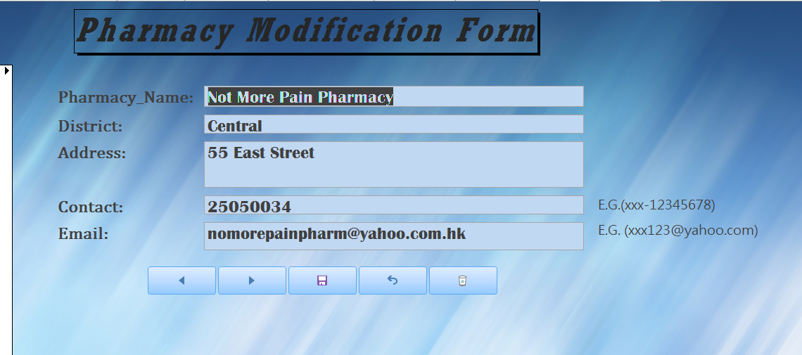

The ninth one performs the function for users to modify the existing data of the records of the table Pharmacy.

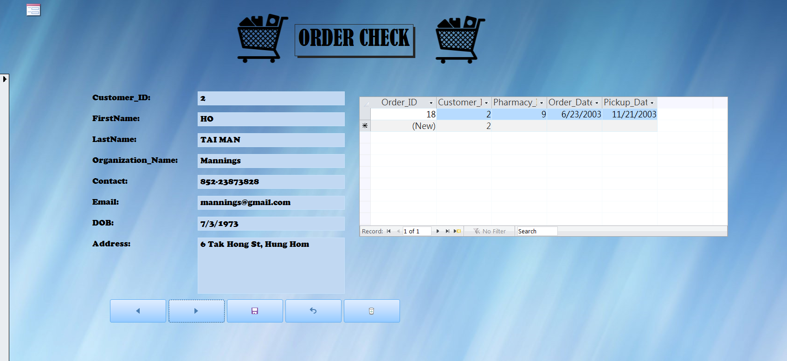

The tenth form is called of the database is called CustomerCHECKORDER which is used to check the customer information for each order. Through this form, users can easily trace and track for the orders and customers at the same time. Besides, there are 5 buttons at the bottom of the form which perform the same function as the 5 buttons of the fourth form.

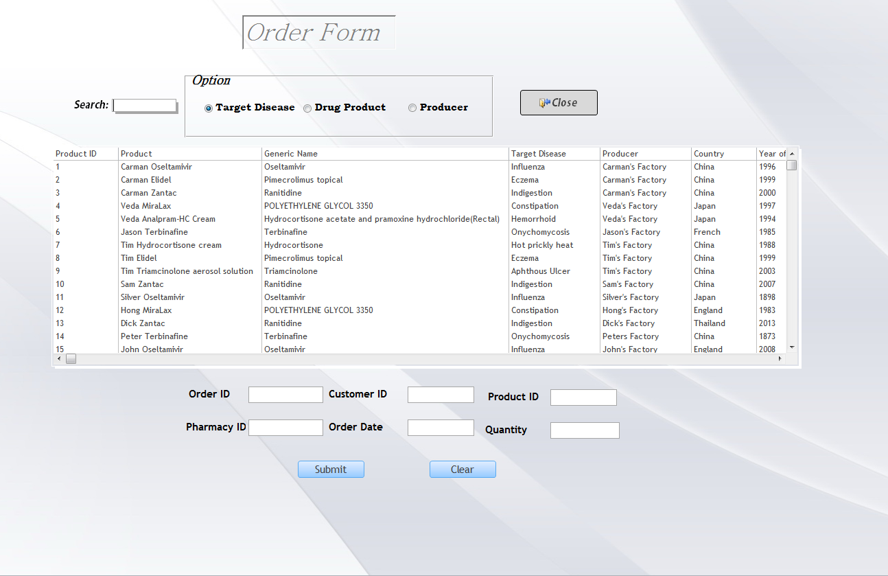

The eleventh form is called Order Form which is used for customers to place an order for their desired drugs and corresponding pharmacy. VBA is used with the “Submit” button, so as to add record in the tables, Orders and OrderItems.

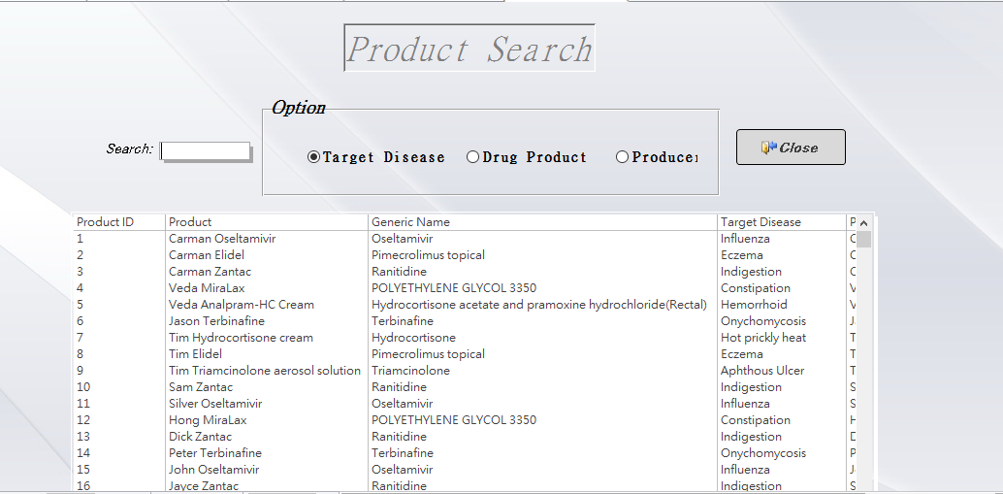

The twelfth form is called Product Search Form which is used for customers or users to search the require products by category. This form is also implemented with VBA so as to perform the searching and filtering function.

The radio buttons, “Target Disease”, “Drug Product” and “Producer”, determine the category that the customers are focusing.

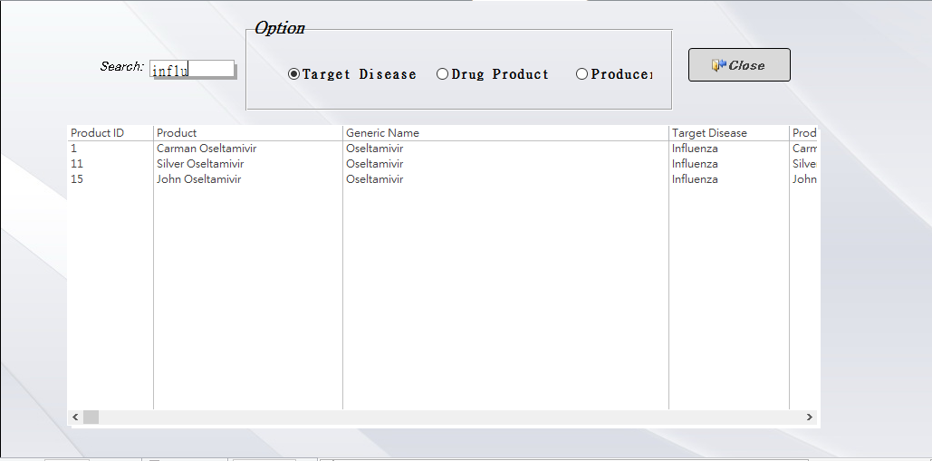

If the radio button “Target Disease” is selected, the target disease of the product will be focused. For example, “influ” is searched when “Target Disease” is selected. The data in the subform will be filtered and only display the product in which its target disease is similar to “influ”.

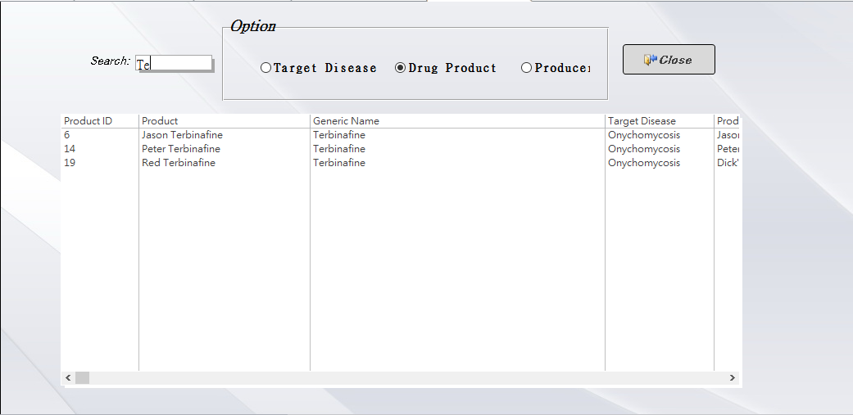

If the radio button “Drug Product” is selected, the name of the product will be focused. For example, “Te” is searched when “Drug Product” is selected. The data in the subform will be filtered and only display the data in which its product name is similar to “Te”.

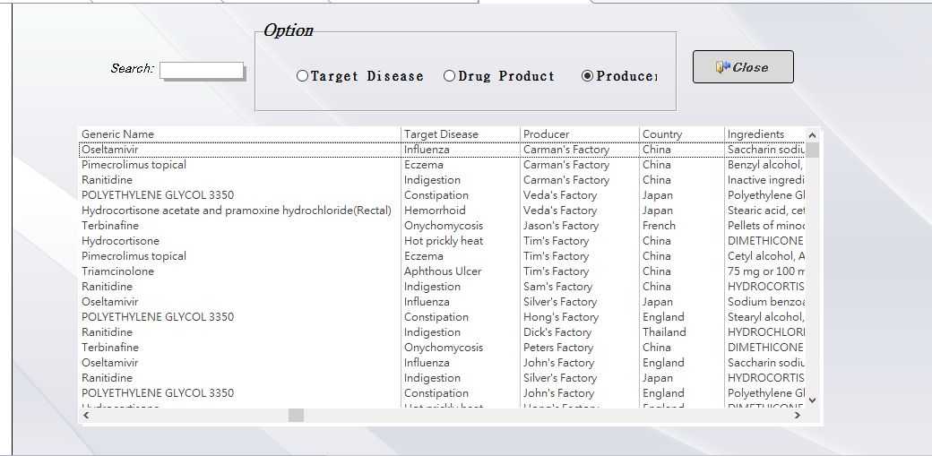

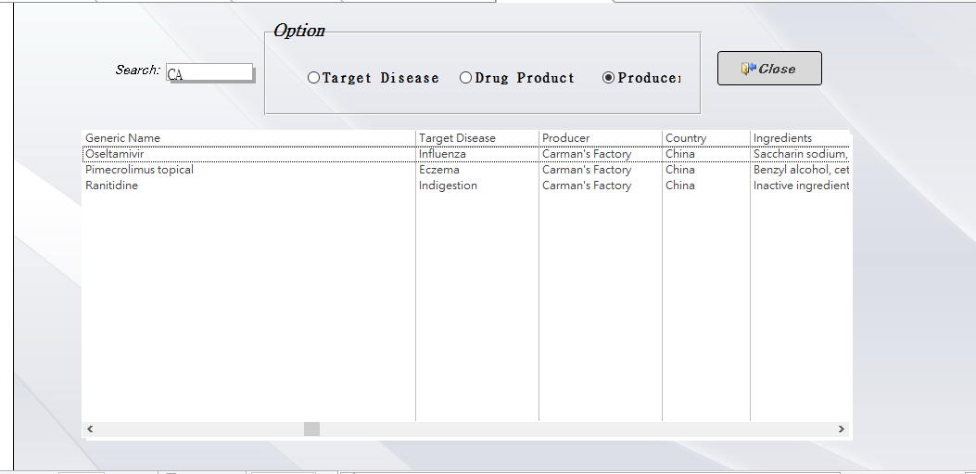

If the radio button “Producer” is selected, the producer of the drug product will be focused. For example, “CA” is searched when “Producer” is selected. The data in the subform will be filtered and only display the data in which its product name is similar to “CA”.

* 1. **Report Design**

There are 4 major reports and 6 sub reports.

1. **Total Fee for Each Order_Report**

This report shows the total fee for each order.

There are three boxes at the bottom to show the total number of orders, quantity and the total amount of money of all orders.

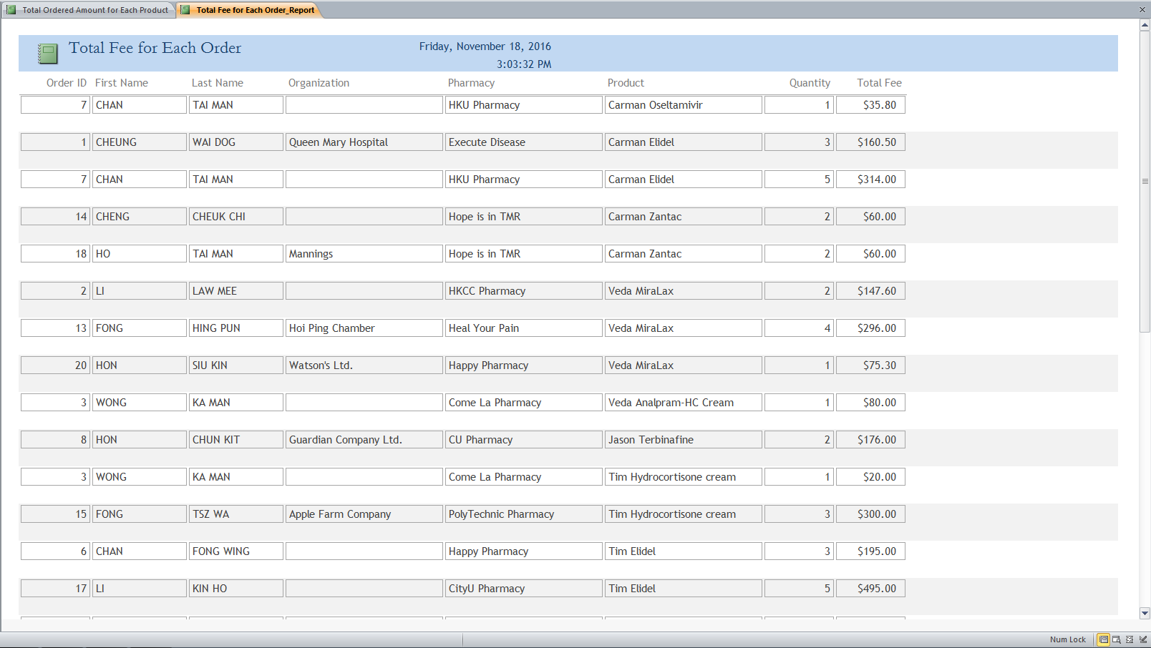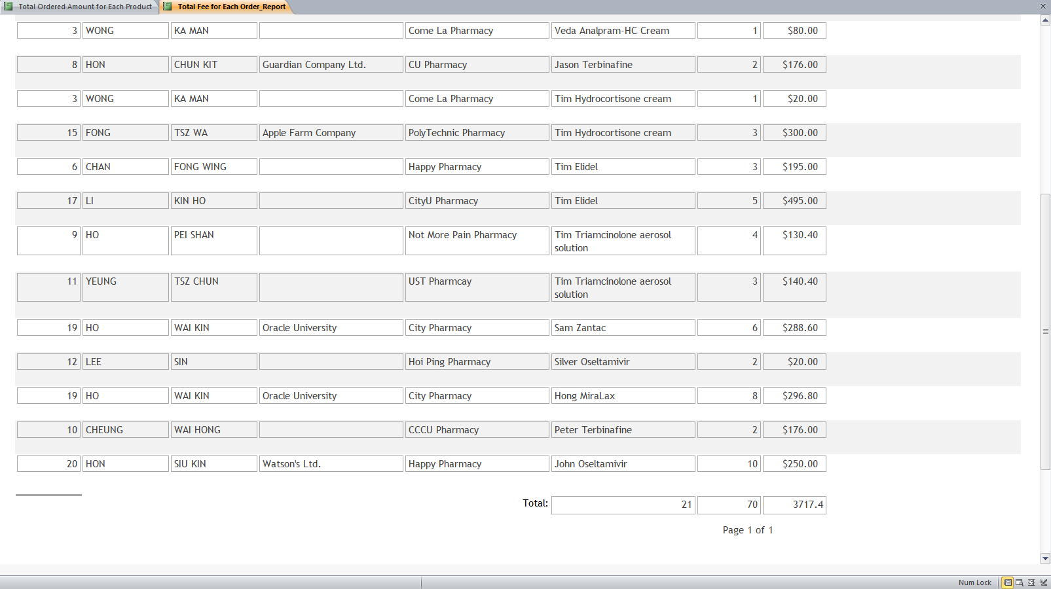

1. **Total Ordered Amount for Each Product**

This report shows the total ordered amount for each product.

There is a graph that tells the users about the total ordered amount clearly.

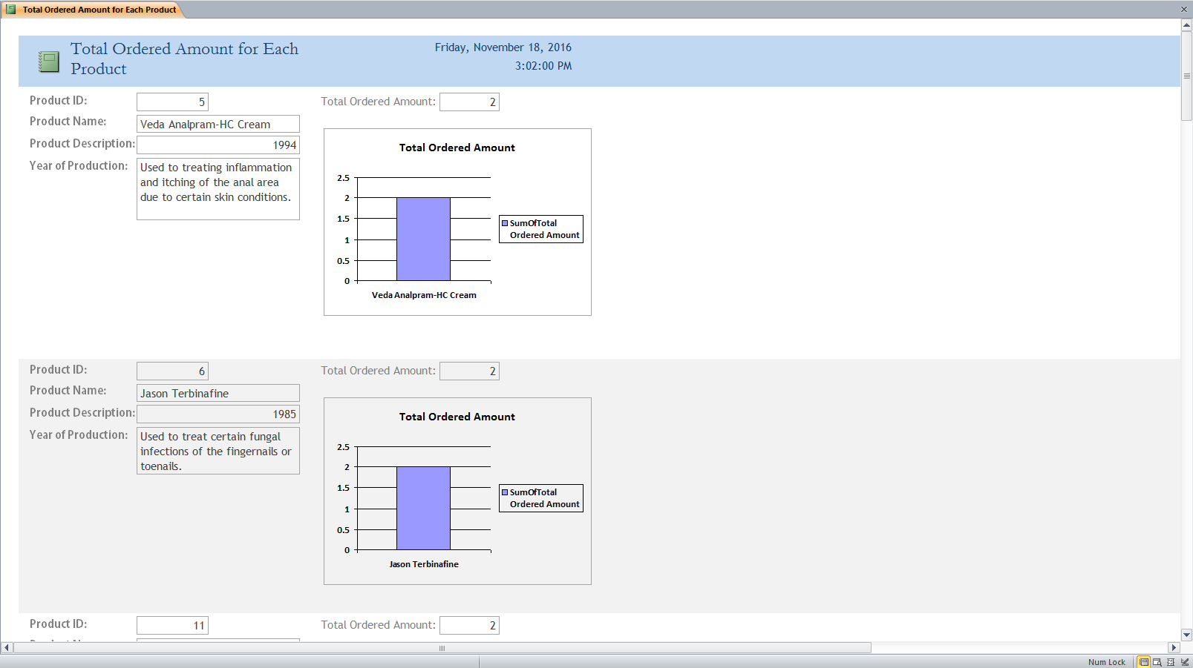

1. **Orders on or after 25/4/2015 Report**

This report allows the user to read the overview information of the Orders table.

The above photo describes the orders that are ordered on or before 24/4/2015.

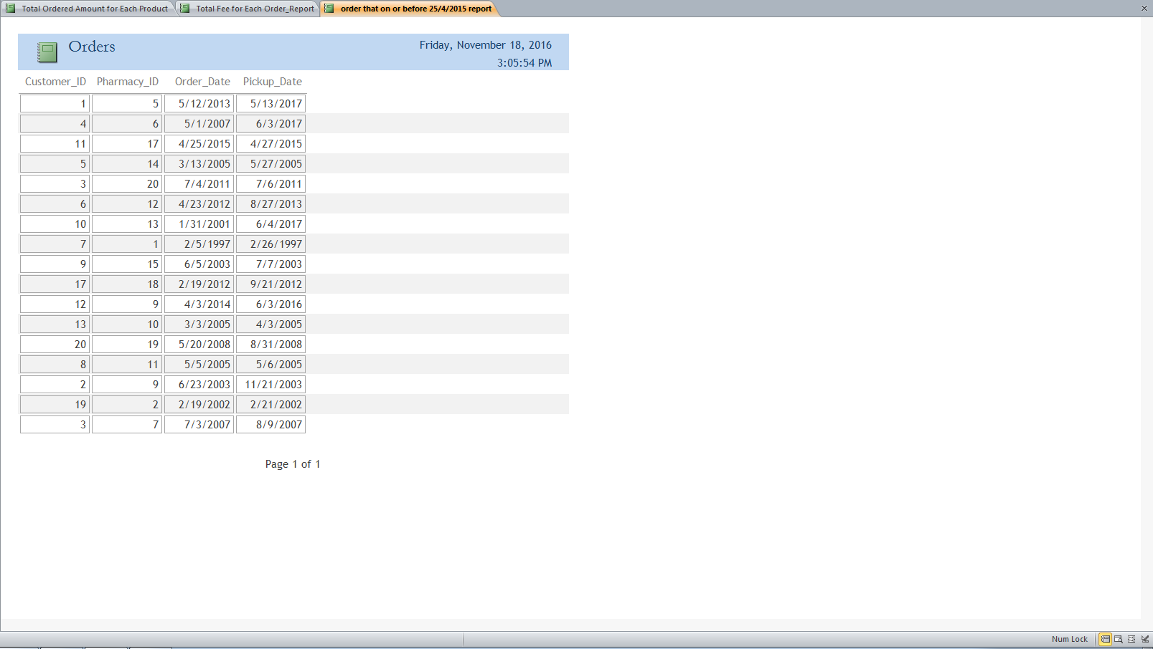

1. **Overview Report for Different Type of Disease**

This report shows the overview report based on the types of disease.

According to our data, there are six subforms to show the drug products of different types.

This report contains 6 subreports:

* Drug Products for Chronic subreport
* Drug Products for Infectious subreport
* Drug Products for Intestinal subreport
* Drug Products for Mouth subreport
* Drug Products for Nail subreport
* Drug Products for Skin subreport

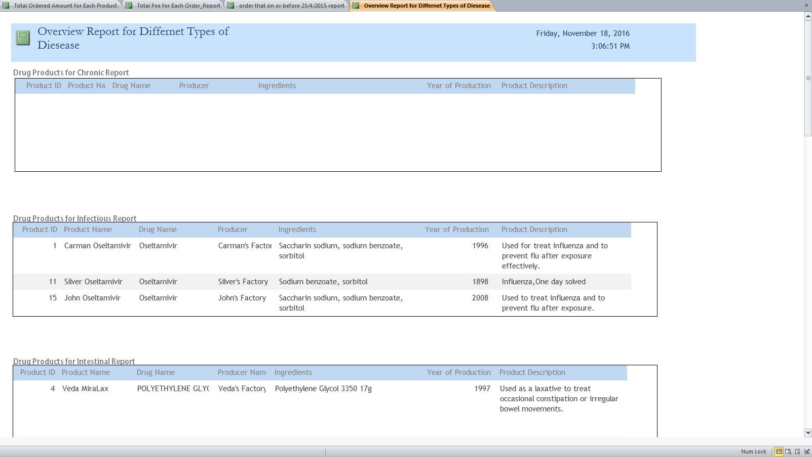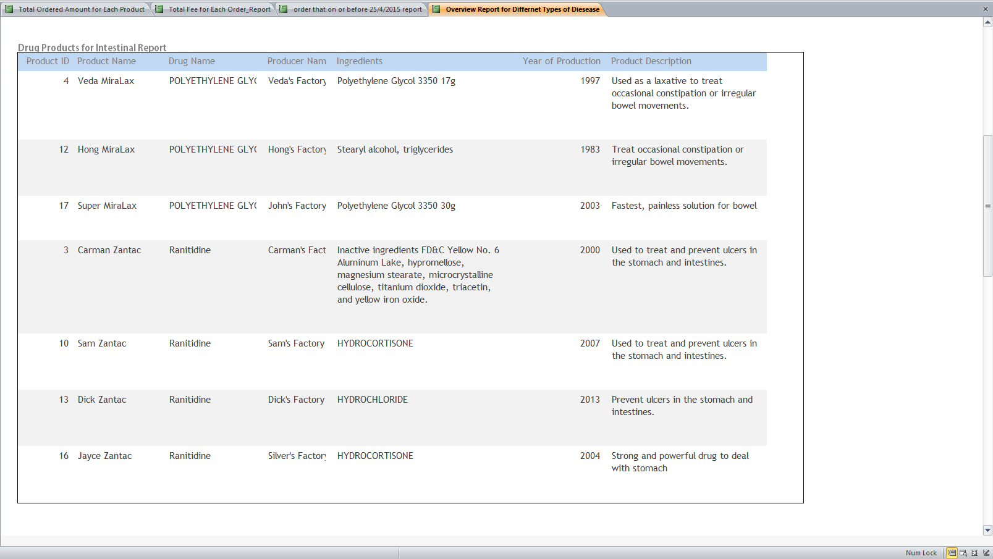

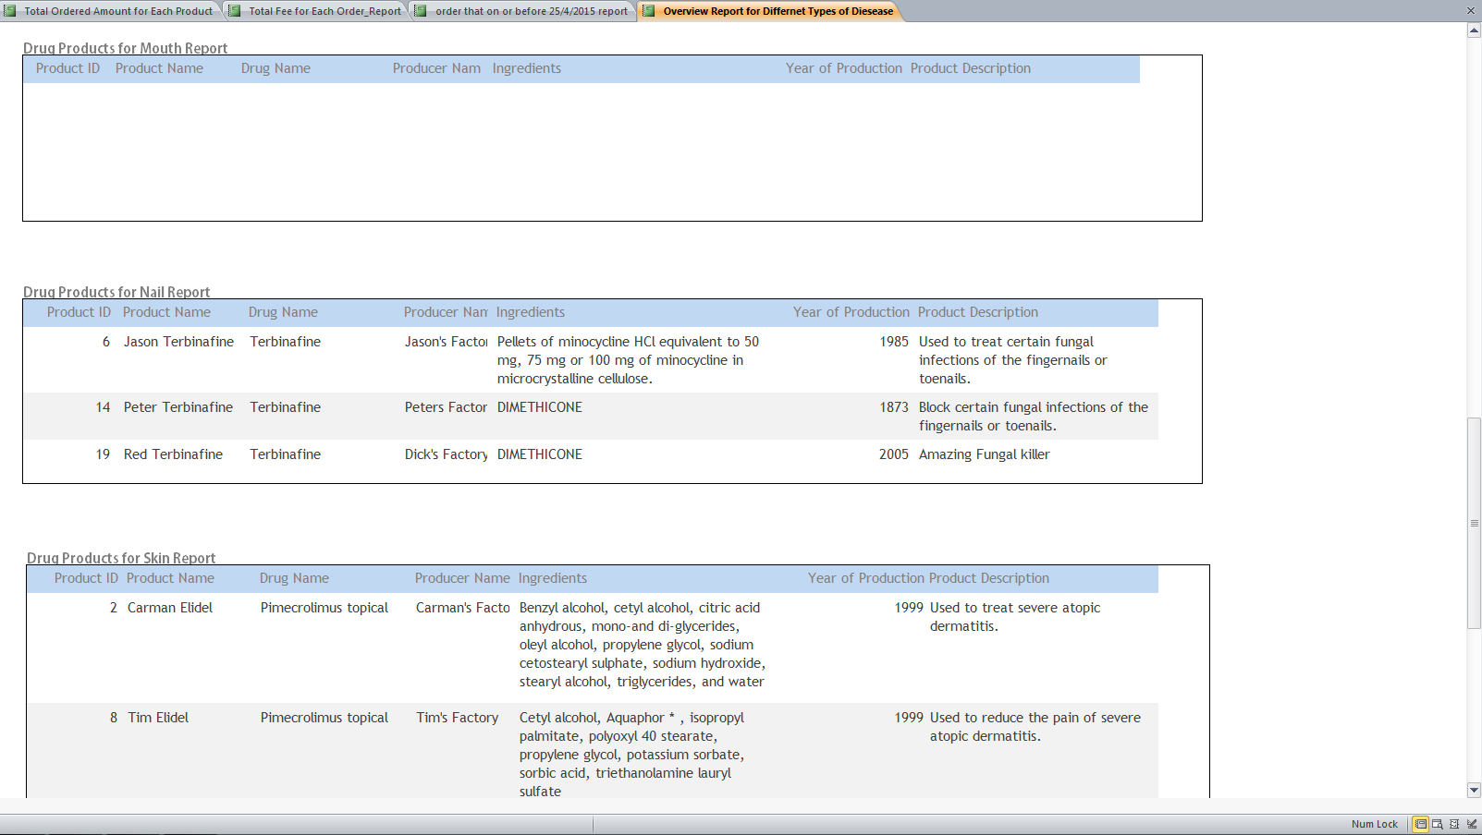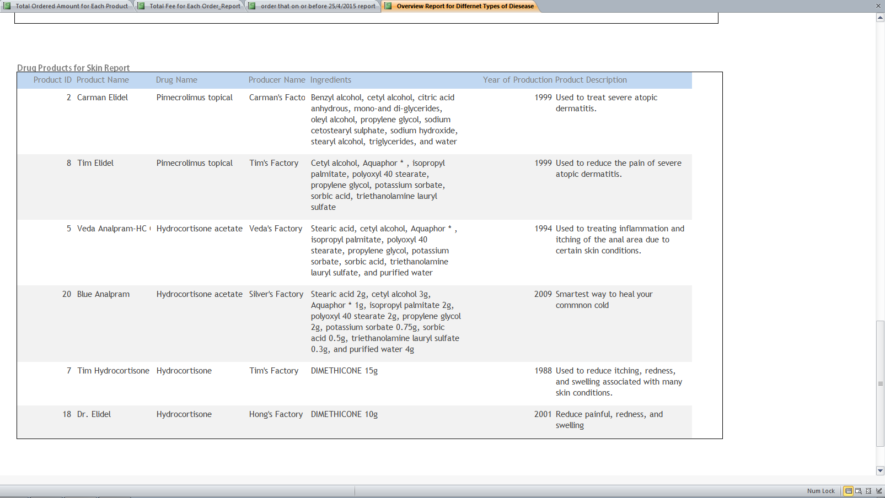

**Difficulties**

1. **Design Phase**

During design phase, resolving the M:N relationships between entities is the most difficult part during design phase. Drugs are in M:N with 3 tables at the same time, Drug Producer, Pharmacy and Orders (refer to the brief conceptual model), which makes the association between tables become complicated. As a result, this becomes a great challenge for our team to resolve the M:N relationships.

1. **Implementation Phase**

During implementation phase, using VBA to create the forms and reports would be the most challenging part. Since no one in our team learnt about the function and syntax in VBA, no one knows how to construct an effective and workable graphical interface for data manipulation and collection. Moreover, it is difficult to add multiple records in multiple tables at the same time using form. High level VBA knowledge and code is required. For example, the Order Form, it is required to add records in table Orders and OrderItems at the same time. Values of the foreign keys are required. However, it is difficult to read the values of a table in VBA and use that value to compare with the values entered by users.

1. **Lessons Learnt**

As mentioned above, resolving M:N relationship and using VBA to create forms and reports are the most challenging parts. In order to solve these two problems, our team has done a lot on researching information on internet. Eventually, we solved the problems by following the tutorial on internet in step-by-step approach. Although our team met a lot of obstacles and challenges, our team still tries our best to finish the tasks since we believe that, “Attitude determines altitude”.

**Work Distribution Schedule**

|  |  |  |  |
| --- | --- | --- | --- |
| **Task Name** | **Start Date** | **Finish Date** | **Responsible** |
| Determine the main theme of database and reasons for implement the database | 24/9 | 30/9 | Li Kin Ho, Ho Wai Kin, Cheung Wai Hong, Hon Chun Kin |
| Determine the business rules for the database | 1/10 | 3/10 | Hon Chun Kin, Cheung Wai Hong |
| Determine the entities involved | 4/10 | 10/10 | Hon Chun Kin, Ho Wai Kin |
| Determine the attributes involved | 11/10 | 12/10 | Cheung Wai Hong, Li Kin Ho |
| Write, revise and submit the project proposal | 13/10 | 15/10 | Cheung Wai Hong, Ho Wai Kin |
| Determine the conceptual design for the database, such as drawing ERD and normalize the database | 16/10 | 20/10 | Hon Chun Kin, Li Kin Ho |
| Determine the logical design for the database, such as translate concepts to attributes, determine the properties of the attributes and apply the data security control, integrity reinforcement | 21/10 | 27/10 | Cheung Wai Hong, Li Kin Ho, Hon Chun Kin |
| Determine the physical design of the database, such as select database management system, decide the data storage medium, determine the source of data and find out the security measures, the access rights of different users | 28/10 | 5/11 | Ho Wai Kin |
| Design the queries, forms and reports | 6/11 | 11/11 | Cheung Wai Hong, Hon Chun Kin |
| Finalize and revise the project report and PowerPoint slides for presentation | 12/11 | 18/11 | Li Kin Ho, Ho Wai Kin |

**Conclusion**

After unstoppable and uncountable revise, our team has finally finished in constructing drug information system. We gained a lot, but we also lost a lot. We gained the experience. We gained the knowledge. We also gained the passion. However, we also lost most of our time since we consume a lot of time on this project. However, we hope that drug information system can really be implemented to help citizens to search for their desired drugs easily. This can really help a lot of patients to stay from diseases. Perhaps it is not a good database system, but we believe that it is the best idea to help citizens to stay away from diseases.

**Reference**

1. <https://stackoverflow.com/>
2. <https://www.oracle.com/index.html>
3. <https://products.office.com/zh-hk/access>
4. <https://www.youtube.com/>